Q1 (a)

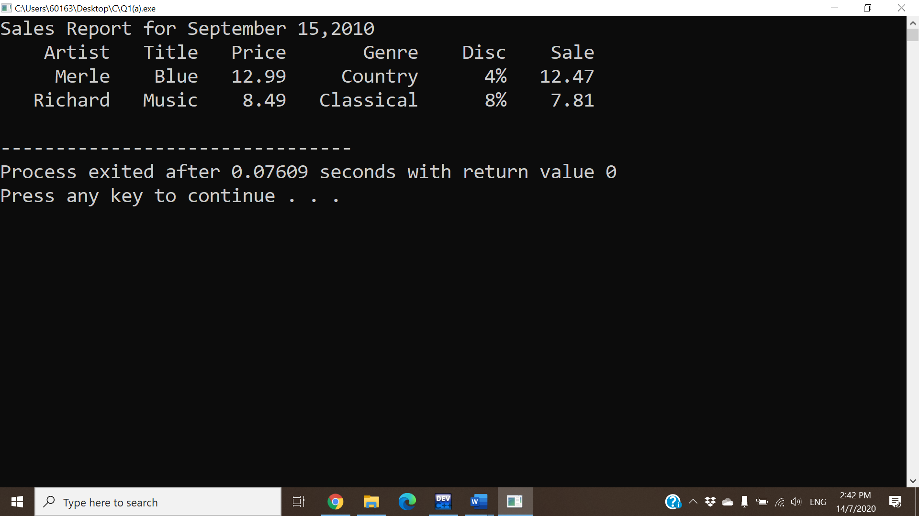

Q1 (b)

#include<iostream>

using namespace std;

int main() {

int x = 8, y = 2, z;

cout << ++x << endl; // 9 (8+1)

cout << x << endl; // 9

cout << x-- << endl; // 9 (memory store x=8)

cout << x + y << endl; // 10 (8+2)

cout << x <<" "<< y << endl; // 8 2

cout << "x * x = "; // x * x =

cout << x * x << endl; // 64 (8*8)

cout << y++ << endl; // 2 (memory store y=3)

z = x % y; // (z = 8 % 3 = 2)

cout << z << endl; // 2

return 0;

}

|  |
| --- |
| Output:  9  9  9  10  8 2  x * x = 64  2  2 |

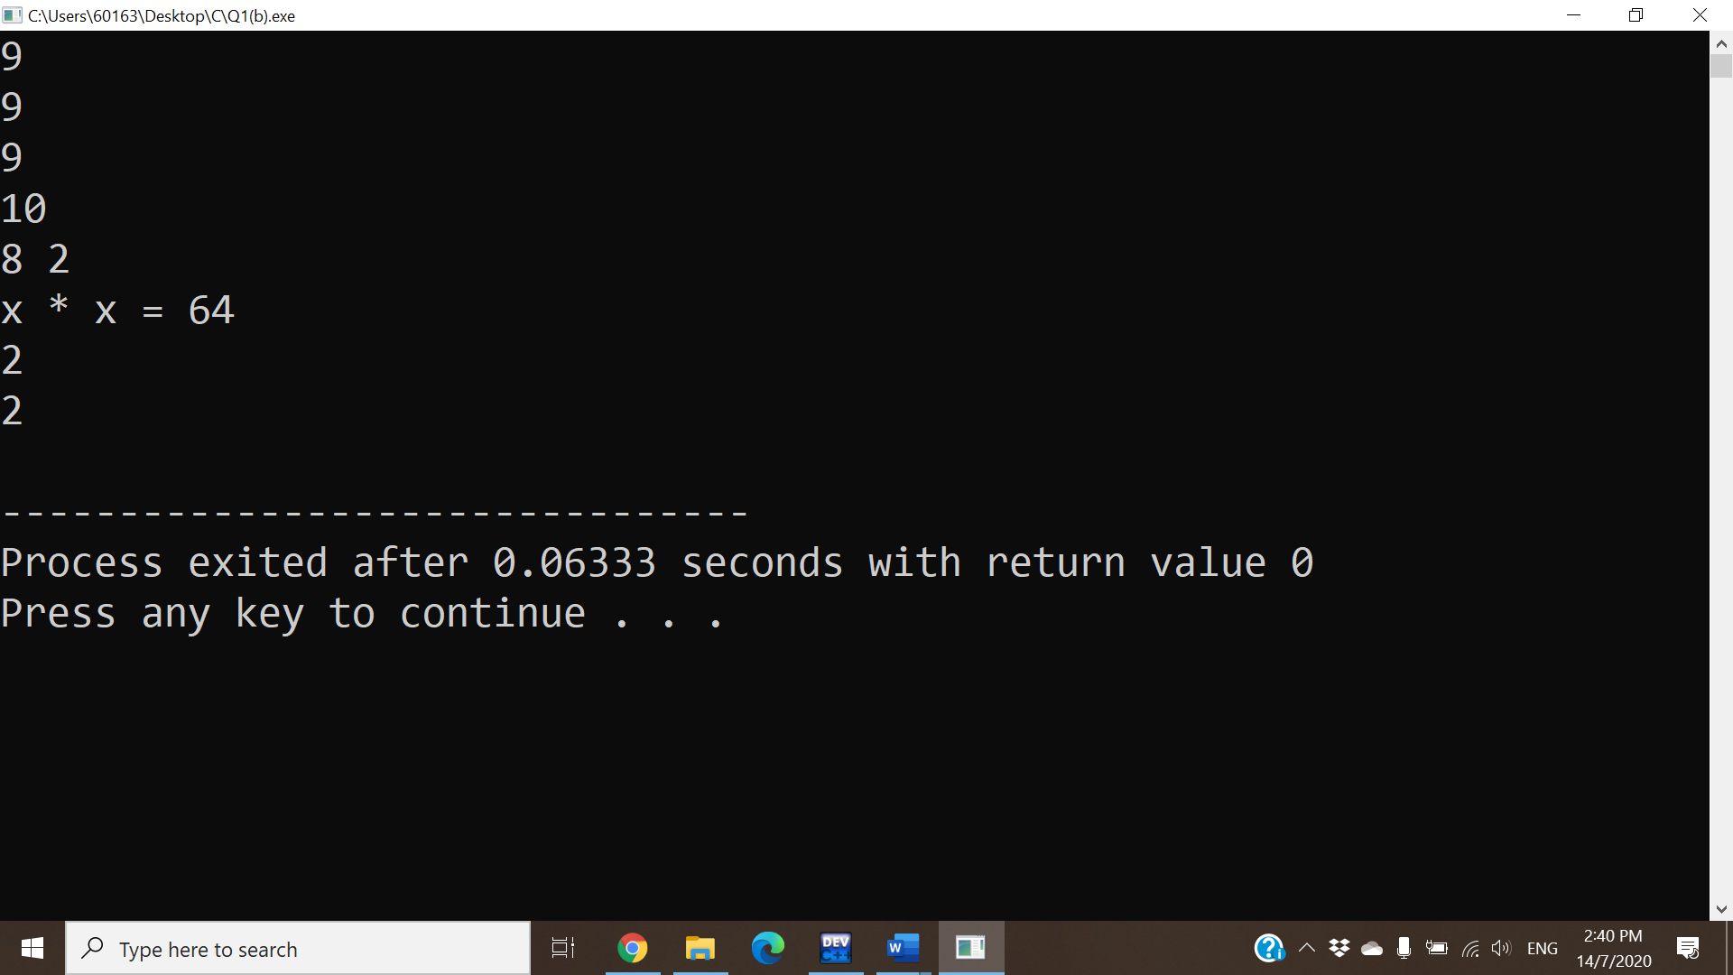

Q1 (c)

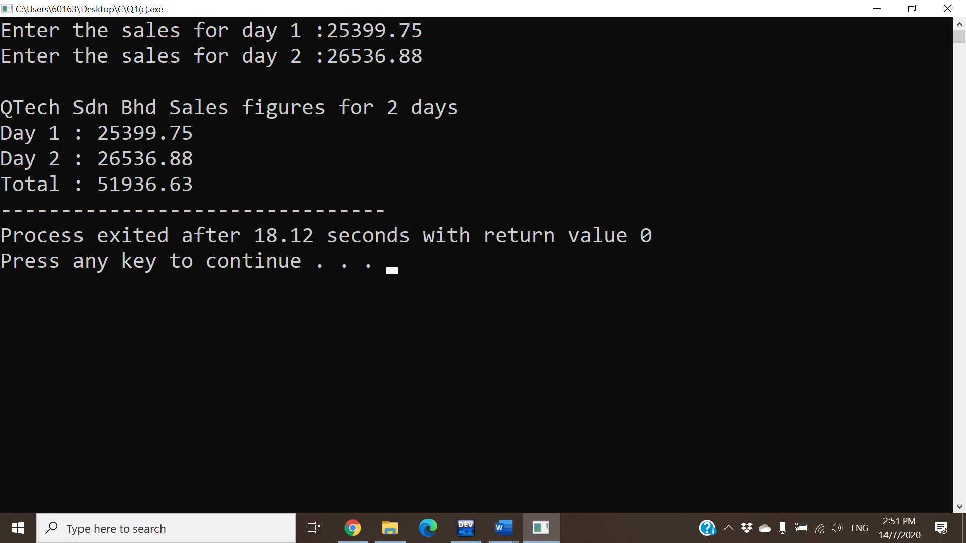

Q2 (a)

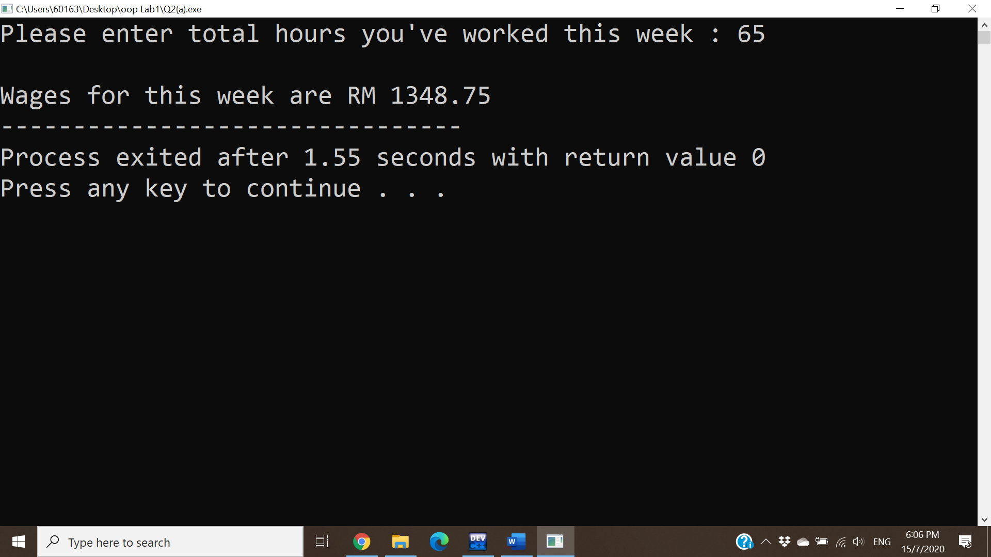

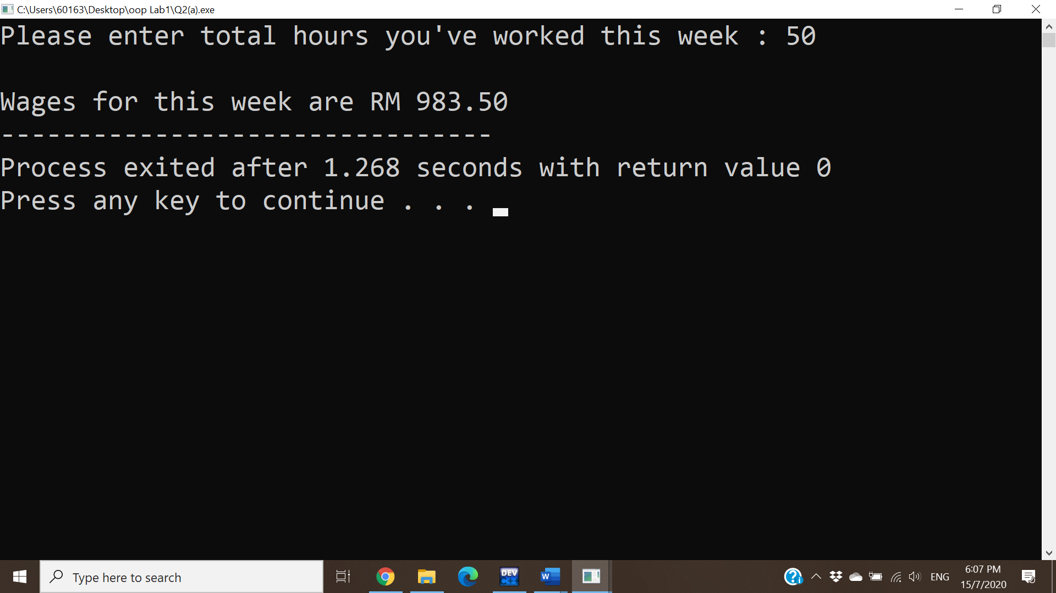

Q2 (b)

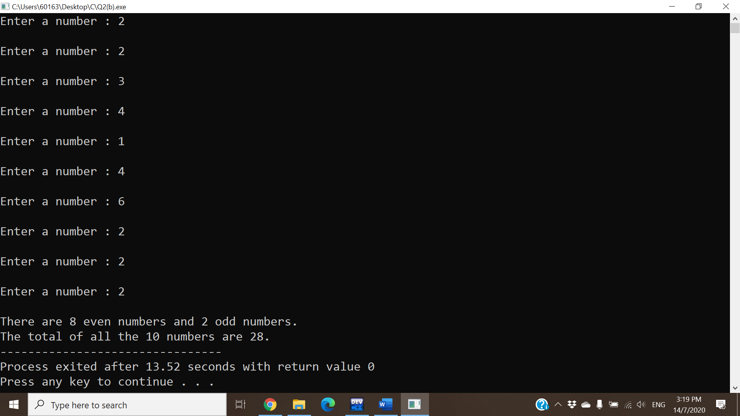

Q2 (c)

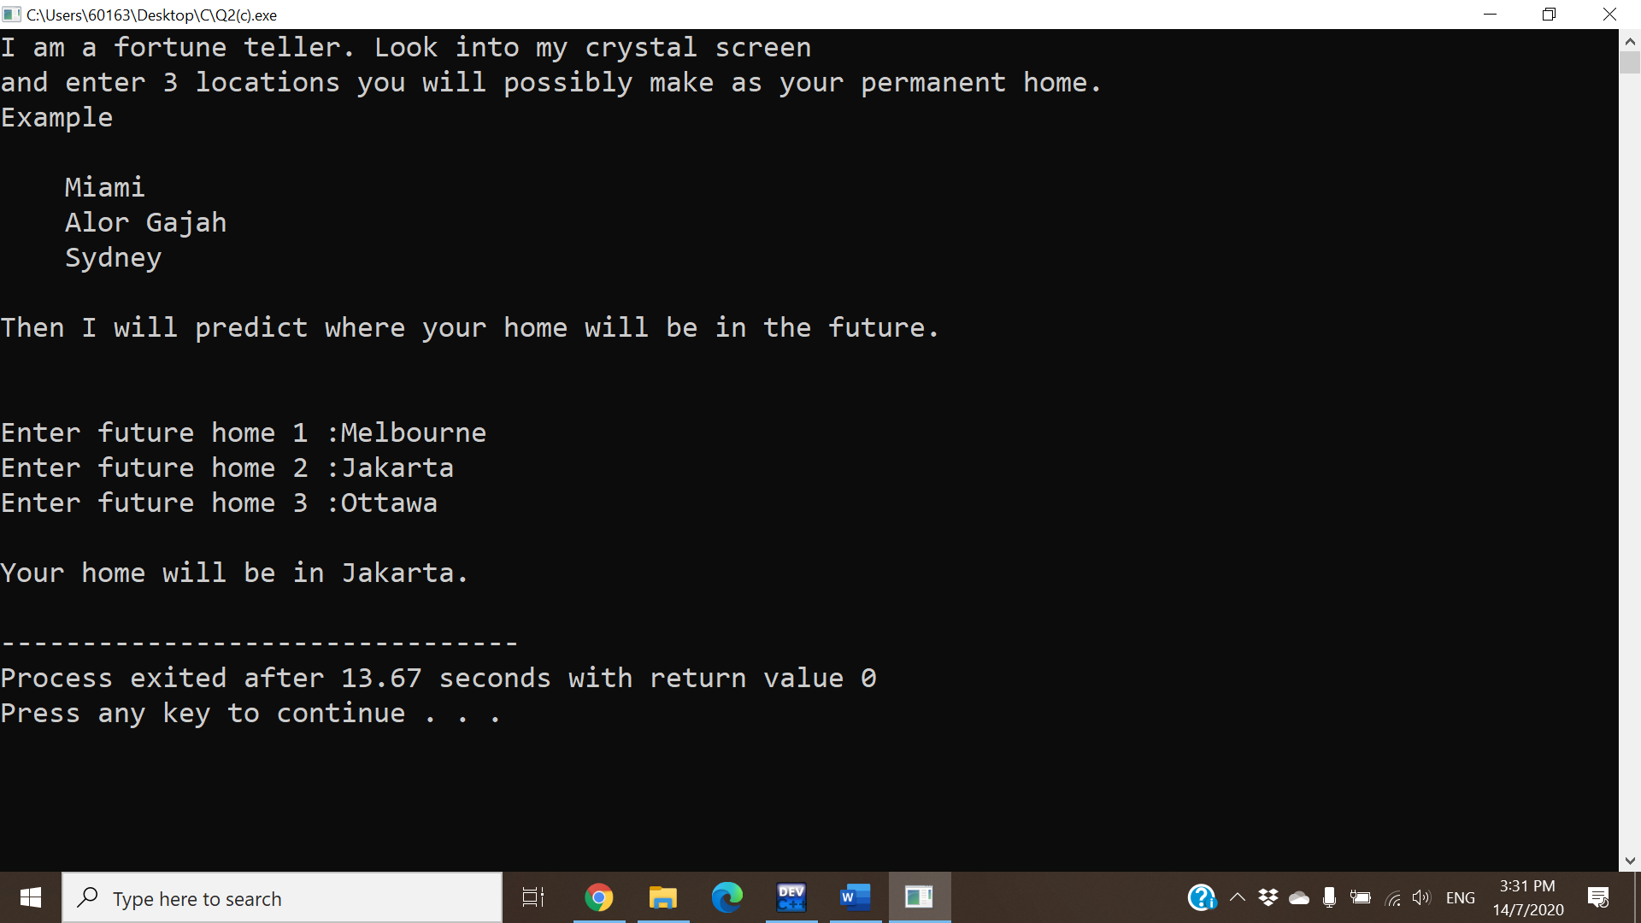

Q2 (d)

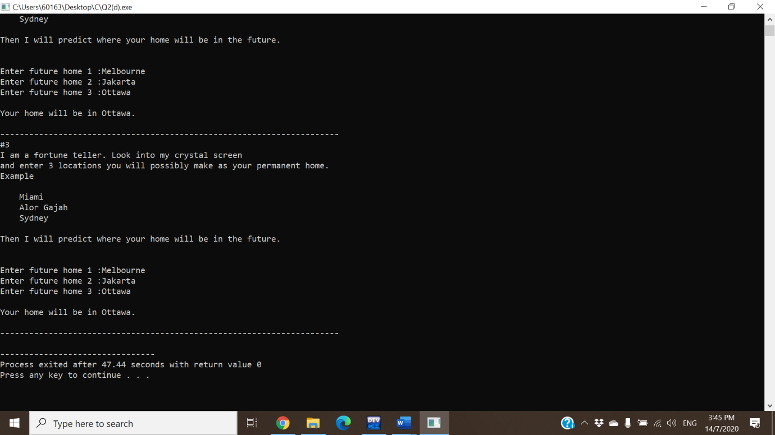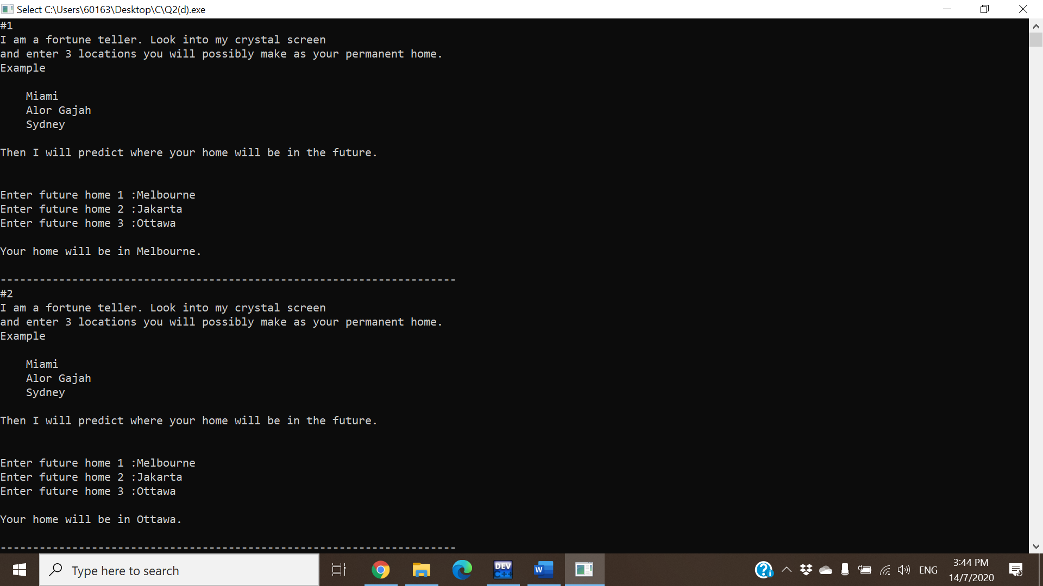

Q2 (e)

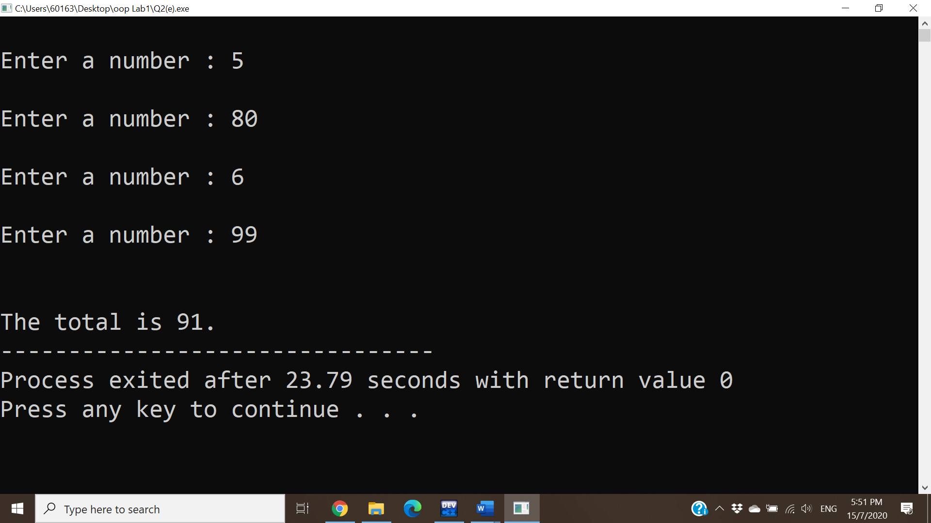

Q3(a)

int a, b;

a b *p *q

int *p,*q;

|  |  |  |  |
| --- | --- | --- | --- |
| 20 | ? | ? | ? |
| 20 | ? | 20 | ? |
| 20 | 40 | 20 | ? |
| 20 | 40 | 20 | 20 |

a = 20;

p = &a; // p ---> a

b = *p%2 + 40; // b = 20%2 + 40 = 0+40

q = p; // q = p ---> a

cout<<"a = "<<a<<endl; // a = 20

cout<<"b = "<<b<<endl; // b = 40

cout<<"*p = "<<*p<<endl; // *p = 20

cout<<"*q = "<<*q<<endl; // *q = 20

|  |
| --- |
| Ouput:  a = 20  b = 40  *p = 20  *q = 20 |

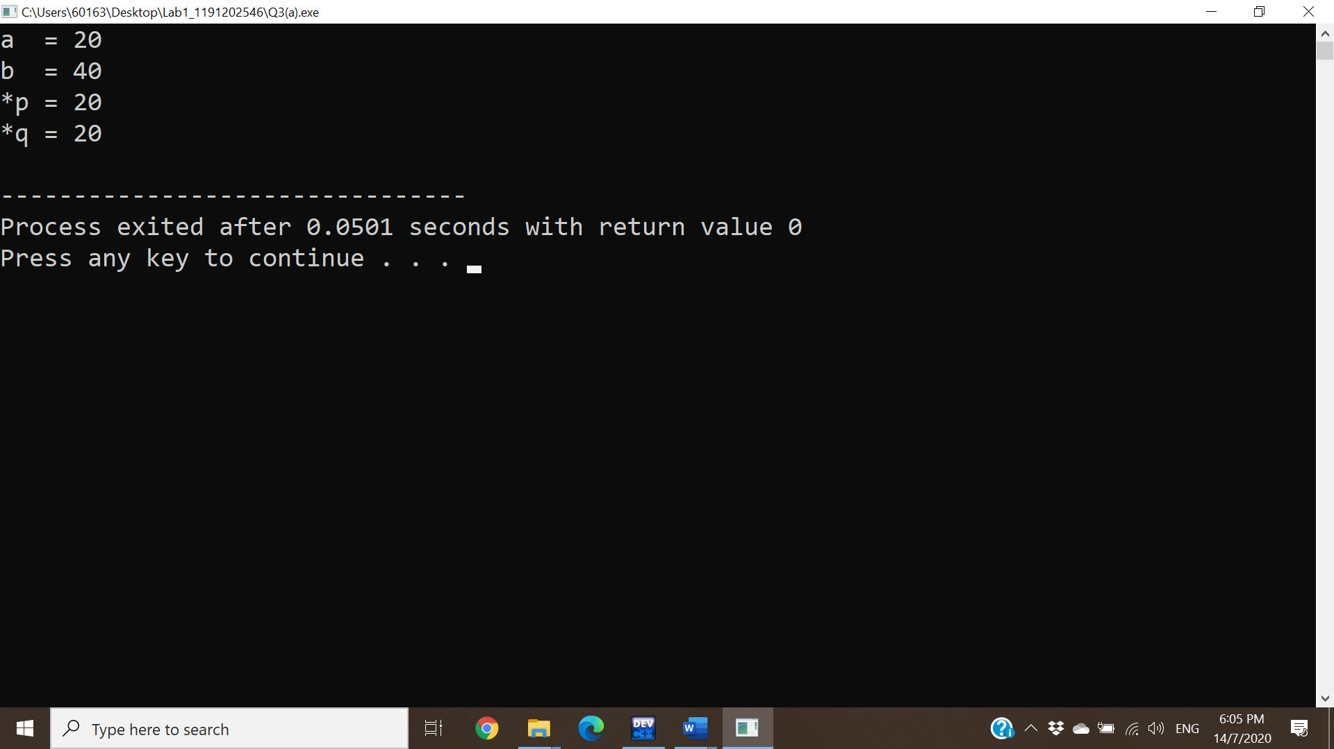

Q3(b)

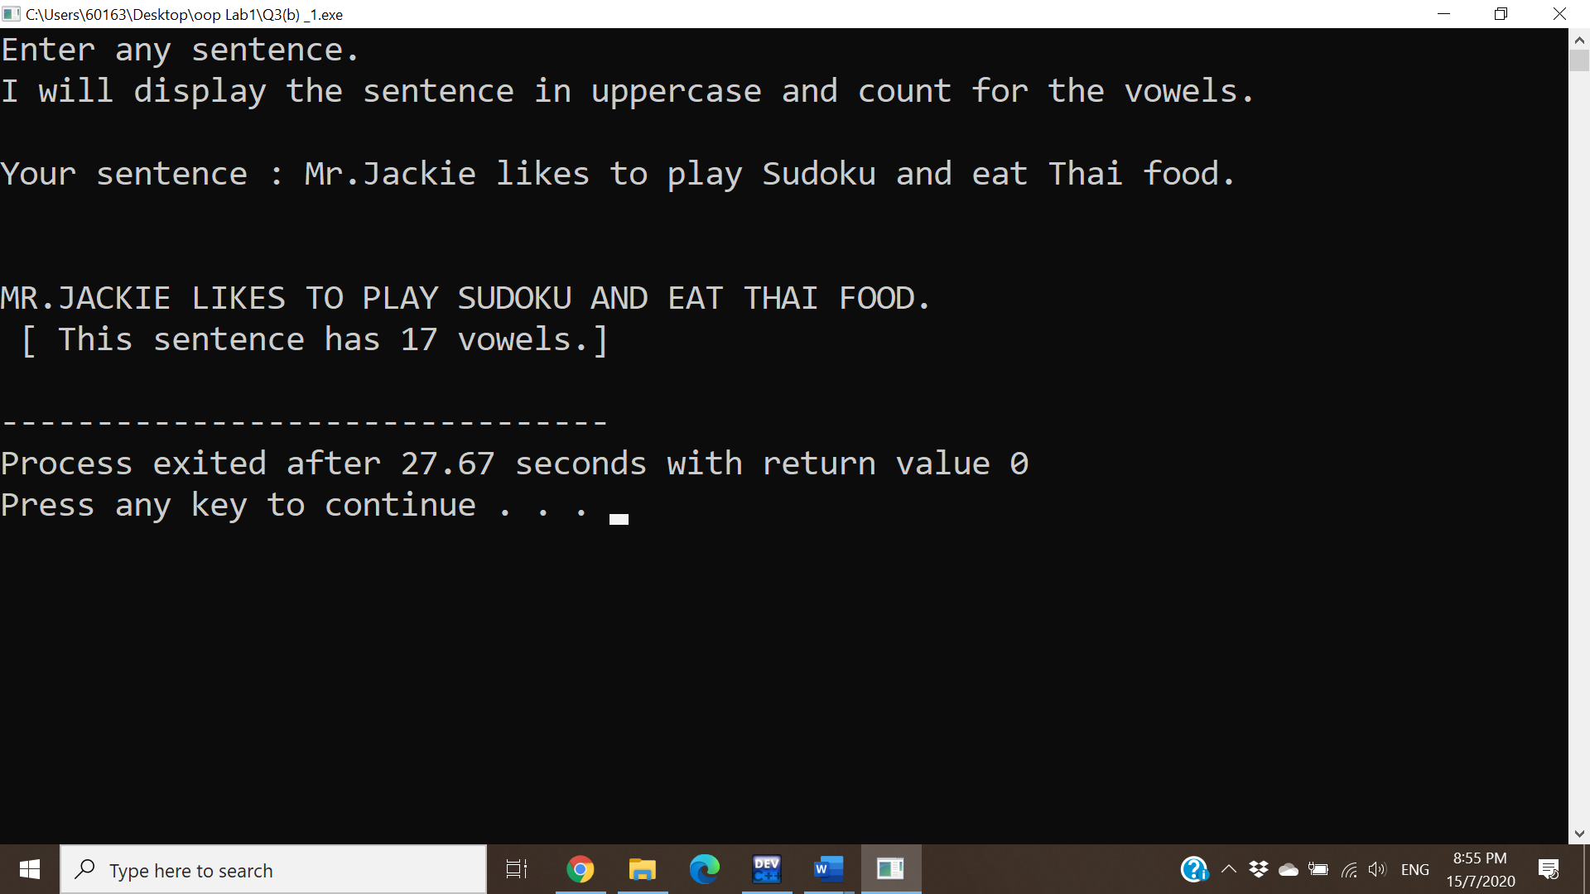

Q3(c)

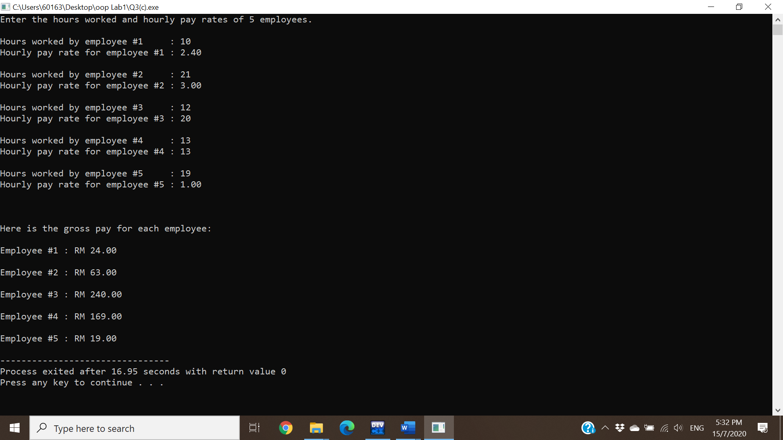

Q3(d)

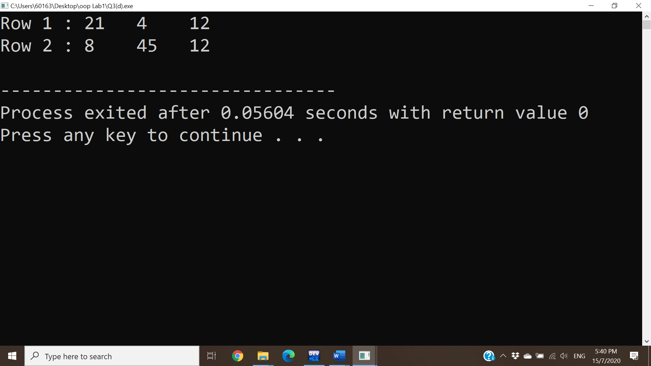

Q4(a)

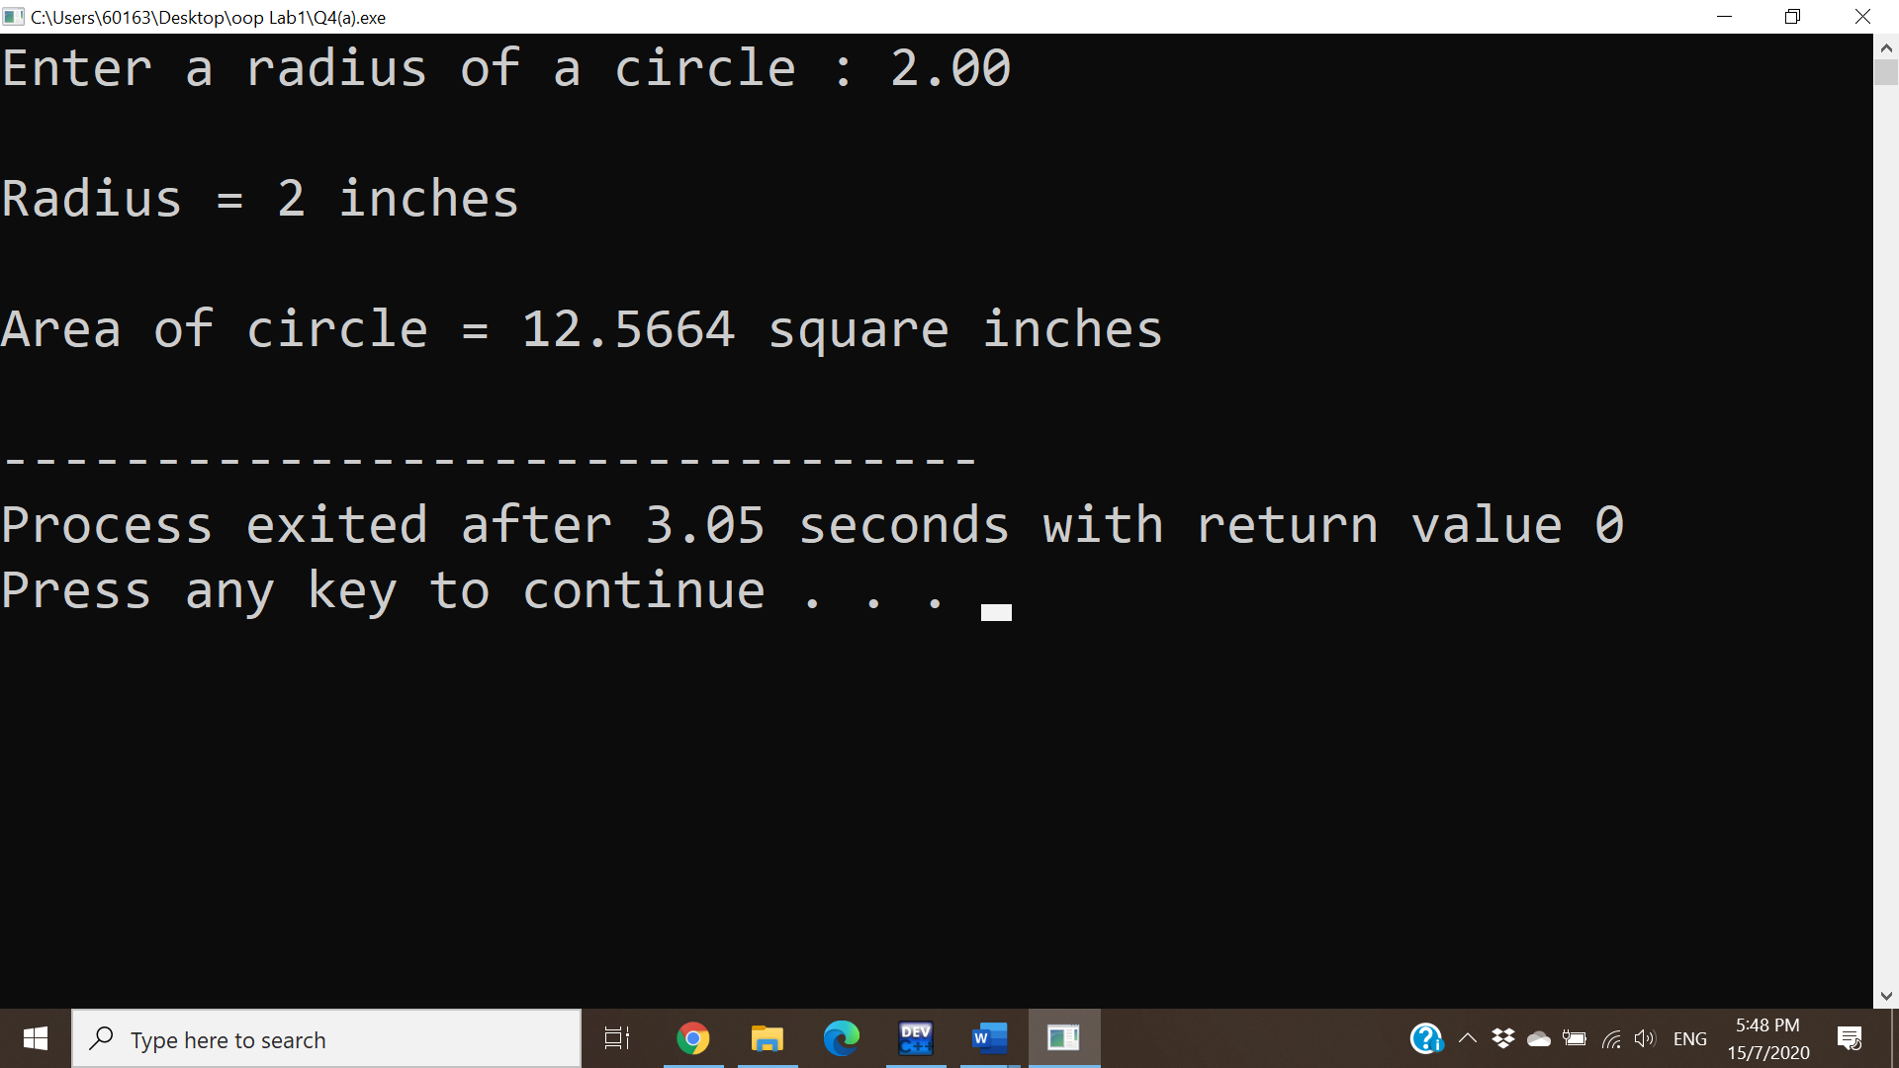

Q4(b)

